

**UNIT 2: PARTS OF A COMPUTER; ASSEMBLING A COMPUTER**

**USEFUL VOCABULARY UNIT 2**

PARTS OF A COMPUTER

* DVD drive
* Fan
* Hard drive
* Heat sink
* Motherboard
* Processor (CPU)
* RAM chip
* Sound card
* USB port
* Cable
* Case
* Frontal panel
* Power supply
* Side panel
* Slot
* Socket
* Switch

ADJECTIVES

* Advanced
* Basic
* Cheap
* Expensive
* Heavy
* Large
* Light
* Little
* Loud
* Narrow
* Quick
* Quiet
* Slow
* Useful
* Useless
* Wide

VERBS

* Attach
* Connect
* Detach
* Disconnect
* Insert
* Plug in
* Remove
* Screw
* Turn off
* Turn on
* Unplug
* Unscrew

**READING AND LISTENING**

1. **Read the website page. Then decide which computer each person below should buy.**

Exercise

* 1. Eva is a graphic designer. She needs to see multiple webpages at the same time.
  2. Carl's favourite free-time activity is playing computer games.
  3. Zoe is a student. She needs to take her computer with her to school.
  4. Tina is a journalist. She needs to upload and download a lot of media files.

1. **A shop assistant (A) is talking to a customer (B). Complete the dialogue with the sentences below.**

Do you want to use it for downloading music or films / Can I help you, sir? / What do you need to use it for? / It’s on special offer this week / What sort of laptop are you looking for? / I think this laptop is what you are looking for

A: 1) Can I help you, sir?

B: Yes. I want to buy a laptop.

A: 2) What sort of laptop are you looking for?

B: I need a small, light computer. I often go on business trips.

A: 3) What do you need to use it for?

B: I need it for Word documents and Excel.

A: 4) Do you want to use it for downloading music or films

B: No, don't, but I need to use the Internet a lot.

A: OK. 5) I think this laptop is what you are looking for? It's light, but it's also fast.

B: How much is it?

A: It's €600. 6) It’s on special offer this week I recommend it.

B: Yes, it's exactly what need, and it’s a good price. What colours does it come in?

A: Blue, black or white.

B: OK. I'd like a blue one, please.

1. **Read the dialogue in Exercise 2 again. Who mentions each of the things below: the salesman, the customer or both?**
   1. Travelling Customer
   2. The names of some computer programs Customer
   3. Downloading music or films Salesman
   4. Using the Internet Customer
   5. The laptop not being heavy Both
   6. Three colors Salesman

**VOCABULARY**

1. **Match the words to the parts of the computer.**

hard drive / motherboard / RAM chip / USB port / sound card /heat sink and fan / DVD drive / processor (CPU)

a. Motherboard

b. Hard Drive

c. USB Port

d. Sound card

f. Processor

e. DVD Drive

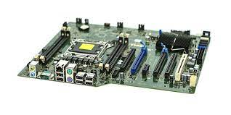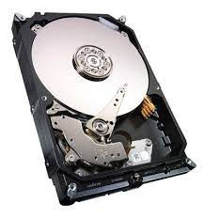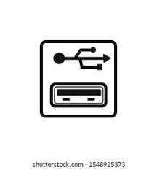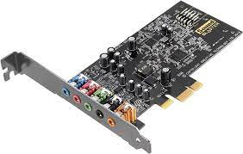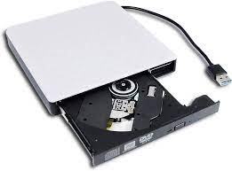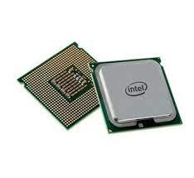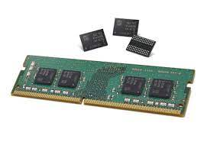

g. RAM Chip

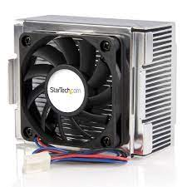

h. heat sink and fan

1. **Match the computer components in exercise 4 to the definitions below.**
   1. This is the computer's brain. 🡪 Processor
   2. This is the main storage space for data. 🡪 Hard drive
   3. This allows the computer to have audio. 🡪 Sound car
   4. This is also called a memory module. 🡪 RAM chip
   5. This stops the processor from getting too hot. 🡪 Heat sink and fan
   6. This contains the main components of a computer. 🡪 Motherboard
   7. This reads and writes disks. 🡪 DVD drive
2. **Match the opposites**

|  |  |
| --- | --- |
| **A** | **B** |
| 1. cheap | A. slow |
| 2. heavy | B. advanced |
| 3. little | C. useless |
| 4. quick | D. expensive |
| 5. basic | E. narrow |
| 6. quiet | F. loud |
| 7. useful | G. light |
| 8. wide | H. large |

1. **Complete the sentences with the words from exercise 6.**
   1. I haven't got enough money for this computer. It's too expensive for me.
   2. My old computer was quite loud, but this one is really quiet.
   3. Modern computers are quite light, not like the old heavy ones.
   4. A more advanced computer model has got better quality hardware.
   5. My motherboard doesn't work! The whole PC is useless now.

**LISTENING**

1. **A salesman is talking to a customer at the computer shop. Listen to their conversation and complete the advert.**

* Large memory and very 1) ………………………..
* Inter core processor
* 2) ……………………….. TB hard drive
* 3) ……………………….. GB RAM memory

PRICE: £ 4) ………………………..

Free 5) ……………………….. and 3 years’ helpdesk support

**New M2 Desktop**

**Computer**

**READING AND LISTENING**

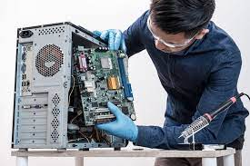

1. **Read the computer manual instructions. Then answer the questions below.**

**HOW TO ASSEMBLE THE COMPUTER:**

1. Unscrew and remove the two side panels of the computer case.
2. Screw the motherboard into place inside the computer case.
3. Open the CPU socket and insert the CPU into the motherboard.
4. Place the heat sink and fan on the motherboard and attach them with the clips.
5. Insert the RAM module into its slot.

**6.** Screw the hard drive into place. Then connect its power cable to the motherboard.

**7.** Insert the sound card and video card into their slots and screw them in.

**8.** Screw the side panels back onto the computer case.

**9.** Plug in all the power and data cables. Turn on the computer and check it works!

Exercise

* 1. How many side panels are there?
  2. Where do you insert the CPU?
  3. What do you use to attach the heat sink and fan?
  4. What do you connect the hard drive to?
  5. What must you do to put the sound card in place?

1. **Peter is speaking to a helpdesk technician. Listen to the dialogue and choose the correct answer.**

A: Hello, I'm Peter Collins at PR Solutions.

B: Hi, Peter. How can I help?

A: I need to install some 1) ***software / hardware*** on my computer.

B: What do you want to install?

A: A new sound card.

B: OK. That's easy. Are you ready? First, turn off and unplug the 2) ***computer / printer.***

A: OK. I've turned it off. Now what?

B: Now, remove the 3) ***panel / cable***. Remove the old card. Then, insert the new sound card into the sound card slot - can you see it?

A: Just a minute. Ok. It's in the slot.

B: Great. Now, screw the sound card into place. There's one 4) ***screw / socket***.

A: Yes, I've got it. OK. What should I do next?

B: Plug in the computer and turn it on. Now, check the sound card is working.

Have you got some 5) ***music / pdf files*** on the computer?

A: Yes. It's working. I can hear it.

B: Good. Finally, put the panel back on the computer and screw it shut.

Can I help you with anything else today?

A: No thanks, that's all. Goodbye.

**VOCABULARY**

1. Match each word to the correct picture.

cable / side panel / case / front panel / power supply / socket / switch / slot

a. side panel

b. socket

c. switch

d. front panel

f. case

e. cable

h. slot

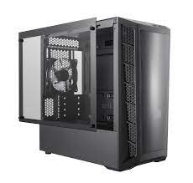

g. power supply

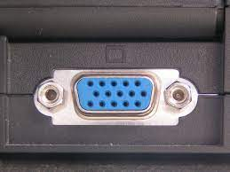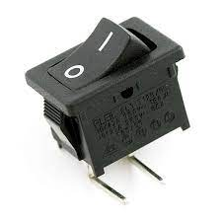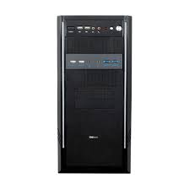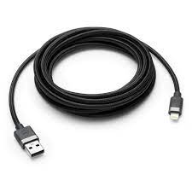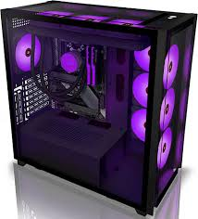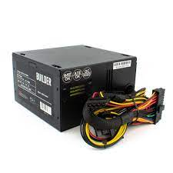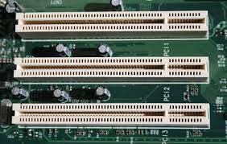

1. **Match the opposites.**

|  |  |
| --- | --- |
| **A** | **B** |
| 1. connect | A. turn off |
| 2. turn on | B. unscrew |
| 3. plug in | C. disconnect |
| 4. screw | D. remove |
| 5. insert | E. unplug |
| 6. attach | F. detach |

1. **Complete the sentences with the words below.**

Cable / power supply / plug in / switch / turn it off / unscrew

* 1. Don't forget to plug the computer into the power supply.
  2. You can connect the monitor to the computer using this cable.
  3. When you've finished using the computer, make sure you turn it off.
  4. Before you remove the motherboard, you have to unscrew it.
  5. Plug in the laptop cable before you turn it on.
  6. This is the main switch to turn the computer on and off.

Verb to be (Past simple)

|  |  |  |
| --- | --- | --- |
| AFFIRMATIVE | NEGATIVE | INTERROGATIVE |
| I was | I wasn’t | Was I? |
| You were | You weren’t | Were you? |
| He was | He wasn’t | Was he? |
| She was | She wasn’t | Was she? |
| It was | It wasn’t | Was it? |
| We were | We weren’t | Were we? |
| You were | You weren’t | Were you? |
| They were | They weren’t | Were they? |

THERE WAS VS THERE WERE

1. There was + singular countable noun / uncountable noun
   1. There was some water in the fridge.
2. There were + plural countable noun
   1. There weren’t any flowers on the table.
3. **Choose the correct answer.** 
   1. In the past, **there were / there weren't** any houses near the stadium.
   2. **Was there / There was** a car park near the athletics track.
   3. Was there a golf course in the village? No, **it wasn't / there wasn't**.
   4. **There were / There was** some good races on TV at the weekend.
   5. **There weren't / There wasn't** a café in the ice rink, but **there were / there was** a bar.
4. **Complete the text with the correct form of WAS, WERE, THERE WAS or THERE WERE. You can use the affirmative or the negative form of the verb.**

Fifteen-year-old Pemba Tamang 1 was at work in a hotel in Katmandu. Suddenly, 2. There was an earthquake. Tamang 3 was trapped in a small hole and 4 couldn´t find any people in the area to help him. 5. There wasn´t water to drink and 6 he found some very small pieces of bread to eat. 7 There were some rescue workers in the area, but they 8 weren´t near Tamang’s hole. His calls for help 9 weren´t loud enough for them to hear. When they discovered him five days later, they 10 were amazed to see him alive.

PAST SIMPLE

Form

* Affirmative 🡪 subject + verb in past 🡪 I played / I saw

*We form the past simple of regular verbs by adding -**ed** to the verb. Some verbs have an irregular past form (list of irregular verbs).

* Negative 🡪 Subject + did not + verb infinitive 🡪 I didn’t see
* Interrogative 🡪 (Wh) + did + subject + verb infinitive ...? 🡪 Did you play?

Use

1. Past habits or states. In this case we can use adverbs of frequency 🡪 She often studied till very late when she was a student.
2. Actions which happened immediately one after the other in the past 🡪 He turned on his computer, connected to the Internet and checked his emails.
3. Complete action or event which happened at a specific past time 🡪 She quit her job last week.
4. People who are no longer alive 🡪 Elvis Presley was a great performer.

Spelling rules (Regular verbs -- Affirmative)

1. We add **-d** to verbs ending in **-e** 🡪 move - moved
2. Verbs ending in **consonant** **+ y** drop the **-y** and add **-ied** 🡪 try - tried
3. Verbs ending in one stressed vowel between two consonants double the last consonant and take **-e** 🡪 drop - dropped
4. Verbs ending in **-**l, double the **-l** and take **-ed** 🡪 travel - travelled

Time words / phrases 🡪 yesterday, the day before yesterday, last week, last month, last year, two hours ago, two months ago, when, then, in 2008....

1. **Complete the sentences with the verbs in brackets in the past simple form.** 
   1. John's coach came to England in 1993. (come)
   2. She stood under a tree to shelter from the rain. (stand)
   3. The cyclist fell off his bike. (fall)
   4. I thought my football team would win. (think)
   5. They swam 500 m. (swim)
   6. The skier wore a new helmet. (wear)
   7. The marathon runners ran the first ten kilometers quite easily. (run)

PAST CONTINUOUS

Form

* Affirmative 🡪 Subject + verb to be in past (was, were) + main verb -ing 🡪 I was playing
* Negative 🡪 Subject + verb to be in past + not + main verb -ing 🡪 You were playing
* Interrogative 🡪 Verb to be in past + subject + main verb -ing ...? 🡪 Was she playing?

Use

1. For an action that was in progress at a stated time in the past. We do not know when the action started or finished (emphasize the course of action) 🡪 She was ironing at 6 o'clock yesterday afternoon.
2. For two or more actions, which were happening at the same time in the past 🡪 Mum was cooking while I was doing my homework
3. To give background information to a story 🡪 It was raining and the wind was blowing when he left home.

Time words / phrases 🡪 yesterday, the day before yesterday, last week, last month, last year, two hours ago, two months ago, when, then, in 2008....

PAST SIMPLE VS PAST CONTINUOUS

1. Past action in progress interrupted by another past action. The longer action is in Past Continuous, the shorter action is in the Past Simple 🡪 I was watching TV when the lights went off.
   1. While/ as + past continuous **BUT** when + past simple
      * I was having a shower when the telephone rang
      * The telephone rang while I was having a shower.
2. **Choose the correct answer to complete the sentence.** 
   1. I **was drawing/drew** a picture while my sister **was listening/listen** to music.
   2. I **parked/was parking** my car when someone **hit/was hitting** me from behind.
   3. I **was doing/did** my homework when my computer **crashed/was crashing**.
   4. It **was snowing/snowed** heavily last night when the car **was getting/got** stuck.
   5. Carrie **forgot/was forgetting** her umbrella and **got/was getting** soaked last night.
   6. We were watching/watched the fireworks at 9 o'clock last night.
   7. First, she **had/was having** a shower and then she **was making/made** breakfast.
3. **Put the verbs in brackets into the past simple or the past continuous. Match the sentences (1-7) to the correct use (a-g).**
   1. Tom and Kate …………………………… (move) to Scotland in 2008.
   2. I …………………………… (do) my homework when suddenly the phone …………………………… (ring).
   3. At nine o'clock last night, Emma …………………………… (watch) the ballet
   4. Lucy …………………………… arrive) at the museum, …………………………… (buy) a ticket and …………………………… (go) inside.
   5. Charlie …………………………… (play) the violin when he …………………………… (be)younger.
   6. Alex …………………………… (shop) online while I …………………………… (book) tickets for the rock concert over the phone.
   7. The sun …………………………… (shine) and the birds …………………………… (sing) when we …………………………… (arrive)at the castle gates.

|  |  |  |
| --- | --- | --- |
| **a** |  | background information to a story |
| **b** |  | actions which happened immediately one after the other in the past |
| **c** |  | an action in progress at a stated time in the past |
| **d** |  | actions happening at the same time in the past |
| **e** |  | an action which was in progress when another action interrupted it |
| **f** |  | a past habit or state which is now finished |
| **g** |  | an action which happened at a definite time in the past |

COUNTABLE NOUS VS UNCOUNTABLE NOUN

1. Countable nouns 🡪 anything that can be counted. They have both a singular and a plural form. They can take a/an in the singular form or any numeral adjective in the plural form.
   1. A dog
   2. Three apples
   3. A lot of pens
2. Uncountable nouns 🡪 anything that cannot be counted. They only have a singular form so they are followed by a singular verb. They cannot take a/an but they can be accompanied by other expressions of quantity.
   1. Some water
   2. No information
   3. A piece of furniture

Uncountable nouns can be classified in the following categories:

* 1. Mass nouns (fluids, solids, gases, particles)
  2. Subjects of study
  3. Languages
  4. Sports and games
  5. Diseases
  6. Natural phenomena
  7. Some nouns 🡪 accommodation, advice, business, chaos, countryside, education, evidence, homework, information, ....
  8. Abstract nouns
  9. Collective nouns 🡪 baggage, furniture, jewellery, luggage, money, rubbish….

Uncountable nouns can be made countable using: **a + expressions of quantity + of 🡪** A bottle of water

1. **Are the nouns in bold countable or uncountable?**
   1. The children fell asleep quickly after the competition.
   2. Be careful! The water in this swimming pool is deep.
   3. We bought three large bottles of mineral water after the race.
   4. How many players are there in the game?
   5. Trainers are giving advice all the time.

EXPRESSIONS OF QUANTITY

|  |  |  |
| --- | --- | --- |
|  | Countable Nouns | |
| Singular | Plural |
| Affirmative | a/an | Some |
| Negative | a/an | Any/no* |
| Interrogative | a/an | Any/some* |

|  |  |
| --- | --- |
|  | Uncountable Nouns |
| Affirmative | Some |
| Negative | Any/No |
| Interrogative | Any/some |

* We use some in questions when we ask for something politely or when we offer something. 🡪 Would you like some orange juice?
* We use no in affirmative sentences to express a negative meaning. → I have no money.

**Much – Many / Few – Little**

1. Mucho
   1. Much + uncountable noun (usually negative and interrogative sentences) 🡪 I have much work to do
   2. Many + countable noun 🡪 I have many friends
2. Poco
   1. A little + uncountable nouns 🡪 Can I have a little milk?
   2. A few + plural countable nouns 🡪 We have a few eggs so we can make an omelette.
3. **Complete the sentences using some or any.** 
   1. We haven’t got ....................................... chocolate.
   2. Are there ....................................... rugs in your house?
   3. There is ....................................... money in my bag.
   4. There isn’t ....................................... water in the sink.
   5. Would you like .............................. orange juice to drink?
   6. I have got ....................................... great news to tell you.
   7. Are there ....................................... tomatoes in the fridge?
   8. Can I have ....................................... milk, please?
   9. There isn’t ....................................... wood outside.
   10. Let’s buy ....................................... chocolate!
4. **Complete the sentences using much or many.**
   1. Jane hasn’t got …………………………………. time.
   2. Do you know …………………………………. words in English?
   3. He didn’t eat …………………………………. meat.
   4. There isn’t …………………………………. butter in the fridge.
   5. There was too …………………………………. noise in the streets.
   6. I cannot see …………………………………. stars in the sky tonight.
   7. Do you have …………………………………. friends abroad?
   8. There isn’t …………………………. water in the rivers at the end of summer.
   9. …………………………………. students couldn’t answer the question.
   10. Can you drink so …………………………………. milk?
5. **Complete the text with: a few, a little, much or many.**

I have just started a fantastic diet! This year I want to be very healthy so I am eating a lot of fresh fruit and vegetables. In the morning I eat …………………………… yoghurt with some honey and …………………………… slices of banana. During the day I don’t eat …………………………… snacks, especially ones that have …………………………… sugar in them. Eating too …………………………… unhealthy snacks can make you put on weight and can cause …………………………… health problems. Instead, I try to have a proper lunch. I find that eating well during the day means I don’t need to eat too …………………………… in the evening. For dinner, I usually have ………………………… pasta or …………………………… pieces of chicken with vegetables. I really love my healthy lifestyle and it makes you feel great!